CLACKAMAS RIVER WATER
1
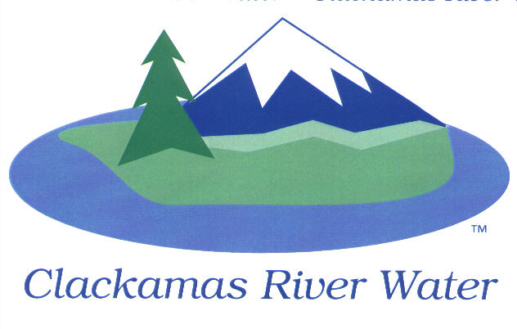
BOARD OF COMMISSIONERS
REGULAR MEETING & WORK SESSION
Held at 16770 SE 82nd Dr.
April 9, 2015

AGENDA

6:00 pm – 8:00 pm
Please sign the attendance sheet. Members of the public are welcome to speak for a maximum of three minutes. Public comment provided at the beginning of the agenda will be reserved for comment on agenda items, special presentations, letters and complaints. Public comment as listed at the end of the agenda will be for the purpose of “wrapping up” any remaining concerns.
REGULAR MEETING @ 6:00 p.m.
Call to Order, Pledge of Allegiance and Roll Call – Larry Sowa, Board President
  - Approval of the Agenda
  - Report on March 16, 2015 Executive Session
Public Comment (see blue box at the top of the agenda)
Consent Agenda
CA-1: Gross Payroll and Accounts Paid: March 2015
CA-2: Cash Position and Transfers: March 2015
Informational Reports
- MANAGEMENT REPORT – Lee Moore Sr., General Manager
- Public Comment (see blue box at the top of the agenda)
Commissioner Business
- Commissioner Reports and Reimbursements –Hugh Kalani and Dave McNeel
Adjourn regular meeting
WORK SESSION @ 6:30 p.m.
Right of Way Fees with Oregon City - Discussion around CRW continuing to charge the Right of Way fee imposed by Oregon City across the entire CRW rate payer base vs. charging the fee only to those customers in Oregon City.
Adjourn work session
Work Session Reminders:
- Work Session – not recorded
- No decisions will be made by the CRW Board
    - Staff may get direction or a sense of the board on key issues
- Members of the public are allowed to attend but not participate
(public comment provided at the end of the session)
The meeting location is accessible to persons with disabilities. A request for accommodations for persons with disabilities should be made at least 48 hours before the meeting to Adora Campbell (503) 722-9226.

