CLACKAMAS RIVER WATER
1
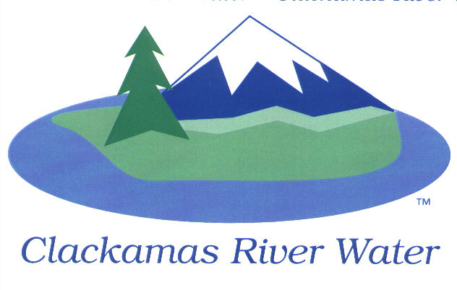
BOARD OF COMMISSIONERS
REGULAR MEETING & EXECUTIVE SESSION
Held at 16770 SE 82nd Dr.
May 14, 2015

AGENDA

6:00 pm – 8:00 pm
Please sign the attendance sheet. Members of the public are welcome to speak for a maximum of three minutes. Public comment provided at the beginning of the agenda will be reserved for comment on agenda items, special presentations, letters and complaints. Public comment as listed at the end of the agenda will be for the purpose of “wrapping up” any remaining concerns.
REGULAR MEETING @ 6:00 p.m.
Call to Order, Pledge of Allegiance and Roll Call – Larry Sowa, Board President
  - Approval of the Agenda
Public Comment (see blue box at the top of the agenda)
Action Items
- Resolution 16-2015: Establishing Wholesale Water Rates Charged to Sunrise Water Authority- Carol Bryck, CFO
Consent Agenda
CA-1: Gross Payroll and Accounts Paid: April 2015
CA-2: Cash Position and Transfers: April 2015
Informational Reports
- Third Quarter financial review- Carol Bryck, CFO
- MANAGEMENT REPORT – Lee Moore Sr., General Manager
- Public Comment (see blue box at the top of the agenda)
Commissioner Business
- Commissioner Reports and Reimbursements –Ken Humberston, Hugh Kalani, Dave McNeel & Larry Sowa
Adjourn
EXECUTIVE SESSION 7:00 p.m.
- Meet to consider the employment of a public officer, employee, staff member or individual agent pursuant to ORS 192.660 (2) (a)
- Discuss information or records that are exempt by law from public inspection pursuant to ORS 192.660 (2) (f) and 192.502 (9).
The Board will recess or adjourn Executive Session.

The meeting location is accessible to persons with disabilities. A request for accommodations for persons with disabilities should be made at least 48 hours before the meeting to Adora Campbell (503) 722-9226.

