CLACKAMAS RIVER WATER
1
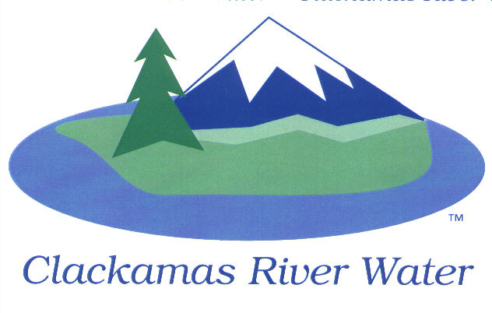
BOARD OF COMMISSIONERS
REGULAR MEETING & EXECUTIVE SESSION
Held at 16770 SE 82nd Dr.
June 11, 2015

AGENDA

6:00 pm – 8:00 pm
Please sign the attendance sheet. Members of the public are welcome to speak for a maximum of three minutes. Public comment provided at the beginning of the agenda will be reserved for comment on agenda items, special presentations, letters and complaints. Public comment as listed at the end of the agenda will be for the purpose of “wrapping up” any remaining concerns.
REGULAR MEETING @ 6:00 p.m.
Call to Order, Pledge of Allegiance and Roll Call – Larry Sowa, Board President
  - Approval of the Agenda
  - Report from Executive Session on May 14, 2015
Public Comment (see blue box at the top of the agenda)
BUDGET HEARING
The hearing of the Clackamas River Water Board of Commissioners, Clackamas County, Oregon will be called to order pursuant to ORS 192.640, 294.438 and 294.453, to allow members of the public an opportunity to testify regarding the CRW budget as approved by the Budget Committee on May 7, 2015 for the biennium July 1, 2015 to June 30, 2017. The budget hearing will be closed by board action and considered for approval on Agenda Item #1.
- Public Comment on BN 2015-2017 Budget
MOTION TO CLOSE BUDGET HEARING
Action Items
- Resolution 17-2015- Adoption of Biennial Budget and make Appropriations for BN 2015-2017- Carol Bryck, CFO
- Resolution 18-2015- Approve Fiscal Year 2014-2015 Budget Appropriation Transfer- Carol Bryck CFO
- Resolution 19-2015- Approve Utility Billing Bad Debt Write-Off for FY 2014-2015- Carol Bryck, CFO
- Resolution 20-2015- Approve Miscellaneous Account Receivable Bad Debt Write-Off for FY 2014-2015- Carol Bryck, CFO
- Resolution 21-2015- Approve the purchase of a restroom/concession facility for Riverside Park – Lee Moore Sr., General Manager
Consent Agenda
CA-1: Gross Payroll and Accounts Paid: May 2015
CA-2: Cash Position and Transfers: May 2015

Informational Reports
- Capital Improvement Projects Update – Adam Bjornstedt, Principal Engineer
- MANAGEMENT REPORT – Lee Moore Sr., General Manager
- Public Comment (see blue box at the top of the agenda)
Commissioner Business
- Commissioner Reports and Reimbursements –Larry Sowa
Adjourn

EXECUTIVE SESSION 7:00 p.m.
- Meet to consider the employment of a public officer, employee, staff member or individual agent pursuant to ORS 192.660 (2) (a)
- Discuss information or records that are exempt by law from public inspection pursuant to ORS 192.660 (2) (f) and 192.502 (9).

The Board will recess or adjourn Executive Session.

The meeting location is accessible to persons with disabilities. A request for accommodations for persons with disabilities should be made at least 48 hours before the meeting to Adora Campbell (503) 722-9226.

