CLACKAMAS RIVER WATER
1
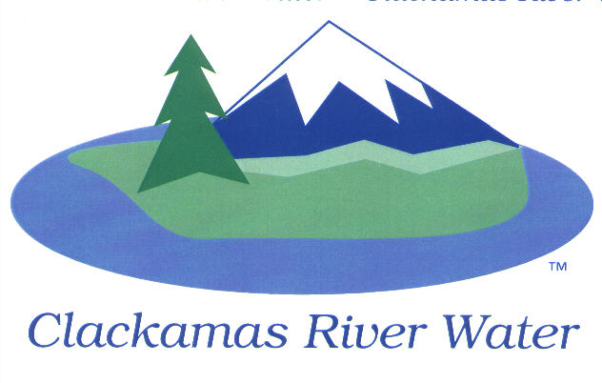
BOARD OF COMMISSIONERS
REGULAR MEETING & EXECUTIVE SESSION
Held at 16770 SE 82nd Dr.
July 9, 2015

AGENDA

6:00 pm – 8:00 pm
Please sign the attendance sheet. Members of the public are welcome to speak for a maximum of three minutes. Public comment provided at the beginning of the agenda will be reserved for comment on agenda items, special presentations, letters and complaints. Public comment as listed at the end of the agenda will be for the purpose of “wrapping up” any remaining concerns.

COMMISSIONER-ELECT OATH OF OFFICE
Public invited.
REGULAR MEETING @ 6:00 p.m.
Call to Order, Pledge of Allegiance and Roll Call – Larry Sowa, Board President
  - Approval of the Agenda
  - Report from Executive Session on June 11, 2015
Public Comment (see blue box at the top of the agenda)
Presentation
CRW Insurance coverage shift to SDAO/SDIS- Jeff Griffin- Wilson-Heirgood
Action Items
- Election of Board Officers – CRW Board of Commissioners
- Election of Board Representatives to the CRWSC Board – CRW Board of Commissioners
- Commissioner Assignments – CRW Board of Commissioners
- Resolution 01-2016: First Reading, by title only, Amending Local Contract Review Board Rules – CRW Board of Commissioners
- Resolution 02-2016: Approve Authorization for Bank Accounts and Check Signatures - Carol Bryck, CFO
- Resolution 03-2016: Adopt and/or Update Investment Policy - Carol Bryck, CFO
- Recurring Payments: Approval of Recurring Payments for Existing FY 2015-2016 Contracts in Excess of General Manager’s Approval Limit - Carol Bryck, CFO
- Resolution 04-2016: Approval of the Inter-Governmental Agreement with the City of Milwaukie of vehicle maintenance.- Lee Moore, Sr. General Manager
- South Butterfield Lane Maintenance Agreement: Board to approve a private road maintenance agreement that provides District access to the Redland Reservoirs- Bob George, Chief Engineer This item is still in legal review and will not be ready for the July meeting
- Consider Contract Award for SE Tolbert St. Waterline Relocation project, CIP 14-5148– Adam Bjornstedt, Principal Engineer

Consent Agenda
CA-1: Gross Payroll and Accounts Paid: June 2015
CA-2: Cash Position and Transfers: June 2015
Informational Reports
- MANAGEMENT REPORT – Lee Moore Sr., General Manager
- Acknowledge the insurance change to SDAO/SDIS– Lee Moore, Sr. General Manager
- Public Comment (see blue box at the top of the agenda)
Commissioner Business
- Commissioner Reports and Reimbursements –Ken Humberston, Hugh Kalani & Dave McNeel & Larry Sowa

Adjourn

EXECUTIVE SESSION 7:00 p.m.
- Meet to consider the employment of a public officer, employee, staff member or individual agent pursuant to ORS 192.660 (2) (a)
- Discuss information or records that are exempt by law from public inspection pursuant to ORS 192.660 (2) (f) and 192.502 (9).

The Board will recess or adjourn Executive Session.

The meeting location is accessible to persons with disabilities. A request for accommodations for persons with disabilities should be made at least 48 hours before the meeting to Adora Campbell (503) 722-9226.

