CLACKAMAS RIVER WATER
1
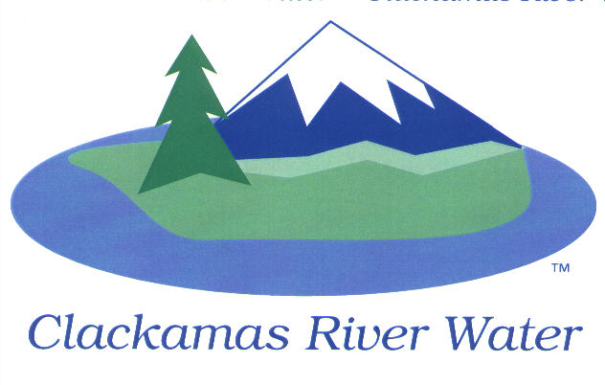
BOARD OF COMMISSIONERS
REGULAR MEETING
Held at 16770 SE 82nd Dr.
August 13, 2015

AGENDA

6:00 pm – 8:00 pm
Please sign the attendance sheet. Members of the public are welcome to speak for a maximum of three minutes. Public comment provided at the beginning of the agenda will be reserved for comment on agenda items, special presentations, letters and complaints. Public comment as listed at the end of the agenda will be for the purpose of “wrapping up” any remaining concerns.

REGULAR MEETING @ 6:00 p.m.
Call to Order, Pledge of Allegiance and Roll Call – Ken Humberston, Board President
  - Approval of the Agenda
  - Report from Executive Session on July 9, 2015
Public Comment (see blue box at the top of the agenda)
Presentation
Drought update- Suzanne DeLorenzo, Water Quality Manager
Action Items

- Acknowledge the insurance change to SDAO/SDIS– Lee Moore, Sr. General Manager

- Approve the extension of the contract with Wilson-Heirgood as the insurance agent of record, Dean Philips Law for legal service and Moss Adams for Auditing services CRW- Lee Moore, Sr., GM

- Approval of surplus property for FY 14/15 – Lee Moore, Sr., GM

- Waterline Easement- Bob George, Chief Engineer

Convene Local Contract Review Board

- Resolution 01-2016: Second Reading, by title only, Amending Local Contract Review Board Rules – CRW Board of Commissioners

Adjourn Local Contract Review Board

Consent Agenda
CA-1: Gross Payroll and Accounts Paid: July 2015
CA-2: Cash Position and Transfers: July 2015
CA-3 GM Salary adjustment
Informational Reports
- MANAGEMENT REPORT – Lee Moore Sr., General Manager
- Public Comment (see blue box at the top of the agenda)
Commissioner Business
- Commissioner Reports and Reimbursements –Naomi Angier, Ken Humberston, Hugh Kalani & Larry Sowa
Adjourn

The meeting location is accessible to persons with disabilities. A request for accommodations for persons with disabilities should be made at least 48 hours before the meeting to Adora Campbell (503) 722-9226.

