1
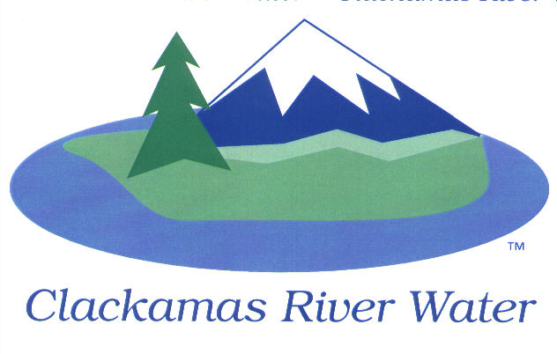

CLACKAMAS RIVER WATER
BOARD OF COMMISSIONERS
REGULAR MEETING
September 11, 2014

AGENDA

6:00 pm – 8:00 pm
Please sign the attendance sheet. Members of the public are welcome to speak for a maximum of three minutes. Public comment provided at the beginning of the agenda will be reserved for comment on agenda items, special presentations, letters and complaints. Public comment as listed at the end of the agenda will be for the purpose of “wrapping up” any remaining concerns.
REGULAR MEETING @ 6:00 p.m.
Call to Order, Pledge of Allegiance and Roll Call – Larry Sowa, Board President
  - Approval of the Agenda
Public Comment (see blue box at the top of the agenda)
- Presentation: FY 2014 Audit Process and Schedule – Julie Desimone, Moss Adams
- Report from Executive Session held on August 14, 2014 - Ken Humberston, Board Secretary
Action Items
- Resolution 03-2015: First Reading of Board Policies, Section 1.12 – Computer Policy
– Lee Moore, Sr., General Manager
- Public Comment
- Project Acceptance: Carver Bridge Transmission Main Phase 1 – North Intertie (CIP 10-5108) – Adam Bjornstedt, Engineering Manager
  - Public Comment
Consent Agenda
CA-1: Donation of Assets: CarMax Auto Superstore, Clackamas Oregon, TLID 2S2E4&5 – Bob George, District Engineer
CA-2: Emergency IGA: Water Environment Services (WES) for Mabel Road Storm and Paving Project – Bob George, District Engineer
CA-3: Gross Payroll and Accounts Paid: August 2014 – Carol Bryck, Chief Financial Officer
CA-4: Settlement Agreement: Ex Commissioner, Katherine Kehoe – Lee Moore, Sr.
Informational Reports
- ENGINEERING: Request for Water Service - CRW Rules and Regulations, Section 9, Exemption Discussion for Service Request Outside CRW Boundary – Bob George, District Engineer
NEXT PAGE
- FINANCIAL REPORT – Carol Bryck
- Debt Covenant Report – FY 2014
- Accounts Receivable/Aging Balance – August 31, 2014
- Cash Position and Transfers – August 2014
- Budget to Actual Update (revisit) – June 30, 2014
- MANAGEMENT REPORT – Lee Moore Sr., General Manager
- Public Comment (see blue box at the top of the agenda)
Commissioner Business
- Confirm Reschedule of October Board Meeting - Thursday, October 16th, 2014
- Schedule/confirm a September Work Session – September 22, 2014
- Commissioner Reports and Reimbursements

Adjourn Regular Meeting

