CLACKAMAS RIVER WATER

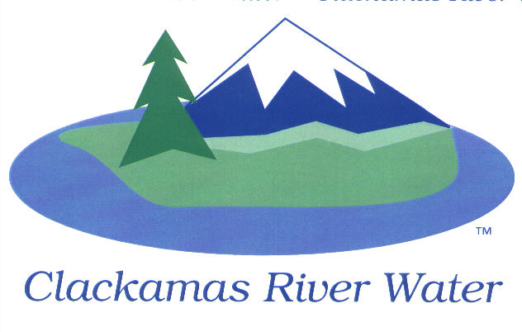
BOARD OF COMMISSIONERS
EXECUTIVE SESSION & REGULAR MEETING
Held at 16770 SE 82nd Dr.
September 17, 2015

AGENDA

3:30 pm Executive Session

6:00 pm Regular Board Meeting
Please sign the attendance sheet. Members of the public are welcome to speak for a maximum of three minutes. Public comment provided at the beginning of the agenda will be reserved for comment on agenda items, special presentations, letters and complaints. Public comment as listed at the end of the agenda will be for the purpose of “wrapping up” any remaining concerns.

EXECUTIVE SESSION @ 3:30 p.m.
- Discuss information or records that are exempt by law from public inspection pursuant to ORS 192.660 (2) (f) and 192.502 (9)
- Meet to consider the employment of a public officer, employee, staff member or individual agent pursuant to ORS 192.660 (2) (a)

Recess or Adjourn Executive Session

REGULAR MEETING @ 6:00 p.m.
Call to Order, Pledge of Allegiance and Roll Call – Ken Humberston, Board President
  - Approval of the Agenda
  - Report from Executive Sessions on August 3, 2015 & September 17, 2015
Public Comment (see blue box at the top of the agenda)
Action Item
Convene Local Contract Review Board
- Increase the General Managers spending authority for public works contracts to $75,000
Adjourn Local Contract Review Board
Consent Agenda
CA-1: Gross Payroll and Accounts Paid: August2015
CA-2: Cash Position and Transfers: August 2015

NEXT PAGE

Informational Reports
- Contract Exemption Justification for Bonding Agent Lewis Young Robertson & Burningham, Inc.- Lee Moore Sr., General Manager
- Preliminary FY 2015 Financial Statement Review – Carol Bryck, CFO
- Debt Covenant compliance reporting
- MANAGEMENT REPORT – Lee Moore Sr., General Manager
- Public Comment (see blue box at the top of the agenda)
Commissioner Business
- Commissioner Reports and Reimbursements –Naomi Angier, Hugh Kalani & Larry Sowa
- Confirm Reschedule of October Board Meeting for October 15, 2015
Adjourn

The meeting location is accessible to persons with disabilities. A request for accommodations for persons with disabilities should be made at least 48 hours before the meeting to Adora Campbell (503) 722-9226.

