CLACKAMAS RIVER WATER

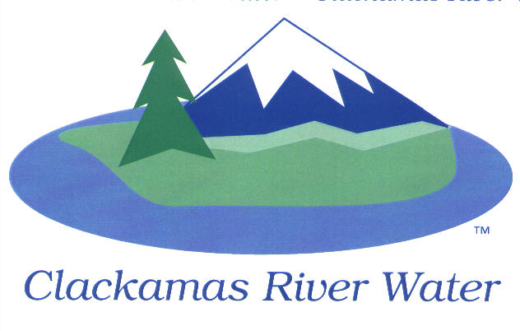
BOARD OF COMMISSIONERS
REGULAR MEETING
Held at 16770 SE 82nd Dr.
October 15, 2015

AGENDA

6:00 pm Regular Board Meeting
Please sign the attendance sheet. Members of the public are welcome to speak for a maximum of three minutes. Public comment provided at the beginning of the agenda will be reserved for comment on agenda items, special presentations, letters and complaints. Public comment as listed at the end of the agenda will be for the purpose of “wrapping up” any remaining concerns.
REGULAR MEETING @ 6:00 p.m.
Call to Order, Pledge of Allegiance and Roll Call – Ken Humberston, Board President
  - Approval of the Agenda
  - Report from Executive Sessions September 17th and 30th, 2015
Public Comment (see blue box at the top of the agenda)
Action Item
- Project Acceptance: SE Bell Avenue – Waterline Relocation, CIP 14-5154 - Adam Bjornstedt, Principal Engineer
- Resolution 06-2016 Reimbursement Resolution – This Resolution will allow for reimbursement of qualified expenses with bonded monies that have been incurred prior to the bond being funded.-Lee Moore, Sr., General Manager
Consent Agenda
CA-1: Gross Payroll and Accounts Paid: September 2015
CA-2: Cash Position and Transfers: September 2015
Informational Reports
- MANAGEMENT REPORT – Lee Moore Sr., General Manager
- Acknowledge the selection of the Bond Counsel – Lee Moore, Sr., General Manager
- Public Comment (see blue box at the top of the agenda)
Commissioner Business
- Commissioner Reports and Reimbursements –Larry Sowa

Adjourn

The meeting location is accessible to persons with disabilities. A request for accommodations for persons with disabilities should be made at least 48 hours before the meeting to Adora Campbell (503) 722-9226.

