CLACKAMAS RIVER WATER
1
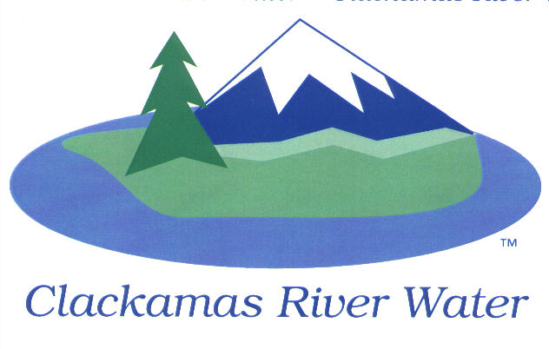
BOARD OF COMMISSIONERS
REGULAR MEETING
October 16, 2014

AGENDA

6:00 pm – 8:00 pm
Please sign the attendance sheet. Members of the public are welcome to speak for a maximum of three minutes. Public comment provided at the beginning of the agenda will be reserved for comment on agenda items, special presentations, letters and complaints. Public comment as listed at the end of the agenda will be for the purpose of “wrapping up” any remaining concerns.
REGULAR MEETING @ 6:00 p.m.
Call to Order, Pledge of Allegiance and Roll Call – Larry Sowa, Board President
  - Approval of the Agenda
Public Comment (see blue box at the top of the agenda)
Action Items
- Resolution 03-2015: Second Reading and Approval of Amending Board Policies, Section 1.12 – Computer Policy – Lee Moore, Sr., General Manager
Consent Agenda
CA-1: Gross Payroll and Accounts Paid: September 2014
Informational Reports
- Estacada Fire: Report on Any Water Quality Concerns – Suzanne DeLorenzo, Water Quality Manager
- FINANCIAL REPORT – Carol Bryck
- Accounts Receivable/Aging Balance – September 30, 2014
- Cash Position and Transfers – September 2014
- Budget to Actual Update – July and August, 2014
- MANAGEMENT REPORT – Lee Moore Sr., General Manager
- Public Comment (see blue box at the top of the agenda)
Commissioner Business
- Confirm Dates for October, November & December Work Sessions
- Commissioner Reports and Reimbursements
Adjourn Regular Meeting to Convene Executive Session
NEXT PAGE

EXECUTIVE SESSION @ 7:00 p.m.
- Discuss information or records that are exempt by law from public inspection pursuant to ORS 192.660 (2) (f) and 192.502 (9)
- Consult with counsel concerning the legal rights and duties of a public body with regard to current litigation or litigation likely to be filed pursuant to ORS 192.660 (2) (h)

Recess or Adjourn Executive Session

