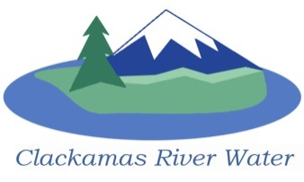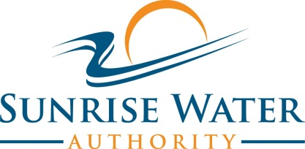

CLACKAMAS RIVER WATER - SUNRISE WATER AUTHORITY

ORS 190 ORGANIZATION
BOARD OF COMMISSIONERS
FIRST MEETING
December 18, 2013

AGENDA

7:30 pm – 9:00 pm

Please sign the attendance sheet.
MEETING @ 7:30 pm
Call to Order, Pledge of Allegiance and Roll Call
- Approval of the Agenda

Action Items
- Appoint Board Members to the ORS 190 Commission
- Appoint Board Officers to the ORS 190 Commission
- Identify Name for the New ORS 190 Organization
- Discuss and Approve Board Operation and Logistics for ORS 190 Organization
Public Comment
Public Comment – (see blue box at the top of the agenda)
Adjourn Regular Meeting

